Guide Of GUI

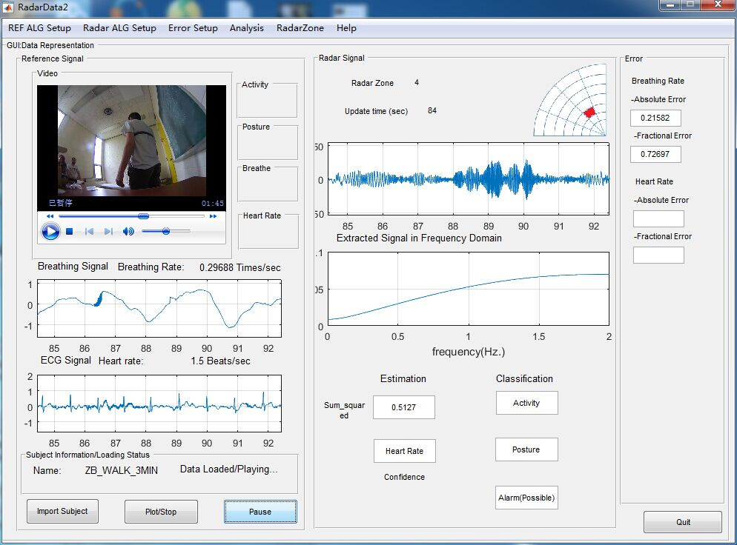

Fig1. User Interface

In order to use this GUI,three files are needed and they should be placed in the same directory.For example:



1. subject_info.csv ------>the radar data file
2. subject_info.mp4(or any video format)
3. Subject_info_BELT.csv(_BELT should be capital)----->data from breathing belt

If you recorded some data yourself,please name them in such manner.

This program may take a lot of time to import the data,don’t click anything when importing...only after the import is complete

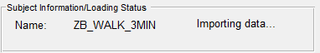

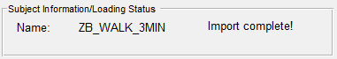

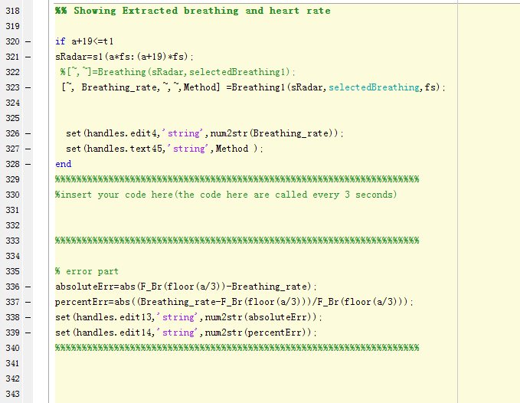

Fig 2. The place where you can insert your code

It’s in RadatData2.m,about line 330,you can insert your own code.It is preferable to write the code as a called function.The code placed here are called every 3 seconds.

E.g.

[Breathing_rate,Method] =Breathing(s1chunk,2,fs);

**The variables that you may use directly:**

rd1: Original radar signals % e.g. rd1(:,1) for radar signal in zone 1

s1 : integrated radar signals

s2 : Original ECG signal

s3 : Original breathing signal

fs : the radar frequency

**The command you may use to set the value:**

set(handles.edit13,'string',num2str(variable));

↑

Change this name tag to communicate with different UI control

The name tag of the UI controls:

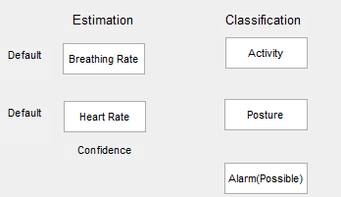 Breathing Rate: edit4

Heart Rate: edit6

Activity: edit5

Posture: edit7

Alarm: edit9

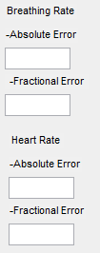

Breathing Rate-

Absolute Error: edit13

Fractional Error: edit14

Heart Rate-

Absolute Error: edit15

Fractional Error: edit16

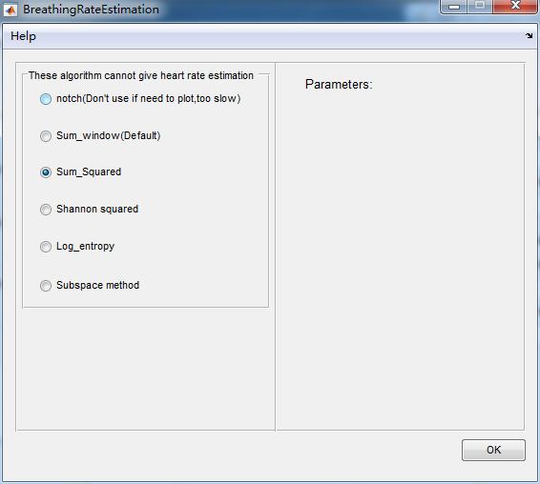

Other available parts:

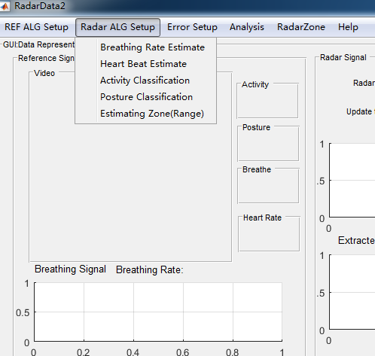

1. The Breathing Rate Estimation Algorithm setup
2. 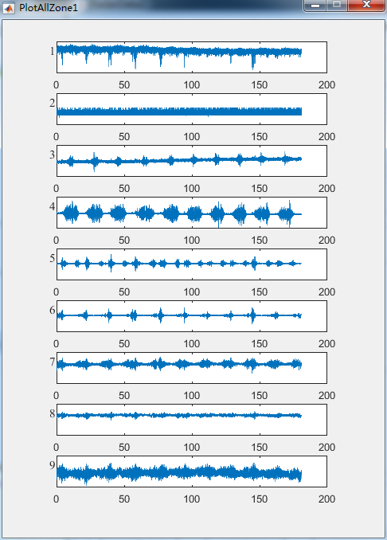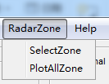

To inspect all the zones